Your Summer Project consists of three parts: journals for How to Read Lit Like a Professor, creating Biblical allusions cards (if you did not create them during your 10th grade year), and reading Frankenstein. Your project will be due on the first day of class and you will be tested on that day, too. If you have any questions about any of these, you can email me at mellolynnette@gmail.com. The Summer Project is also on my webpage: http://www.djuhsd.org/Delano%20High/Class/2743-Advanced-Placement-Literature-and-Composition

Make sure you sign up for my text alerts by texting @mellol to 585-245-0333.

Part 1: Journal Questions for How to Read Literature Like a Professor by Thomas Foster.

As you read through this book, answer the following questions in your reading journal. All questions should be answered fully and neatly. I prefer each entry to be typed. One entry per page with each page clearly labeled as to which chapter you are answering. Most of these journals will be less than one page but at least one meaty paragraph. This will be due on the first day of class and you will be tested on your knowledge of the ideas Foster writes about.

NOTE: I am very aware of what is out on the internet in terms of this project. Your job is to THINK your own thoughts, not just regurgitate the thoughts/ideas of others. If I suspect that you have plagiarized any of the entries from someone else other than yourself, you will fail this assignment.

Introduction: How'd He Do That?
How do memory, symbol, and pattern affect the reading of literature? How does the recognition of patterns make it easier to read complicated literature? Discuss a time when your appreciation of a literary work was enhanced by understanding symbol or pattern.

Chapter 1 -- Every Trip Is a Quest (Except When It's Not)
List the five aspects of the QUEST and then apply them to something you have read (or viewed) in the form used on pages 3-5.

Chapter 2 -- Nice to Eat with You: Acts of Communion
Choose a meal from a literary work and apply the ideas of Chapter 2 to this literary depiction.

Chapter 3: --Nice to Eat You: Acts of Vampires
What are the essentials of the Vampire story? Apply this to a literary work you have read or viewed. (NOTE: You cannot use an actual vampire story for this one—no Twilight books, please).

Chapter 4 -- If It's Square, It's a Sonnet
Select three sonnets and show which form they are. Discuss how their content reflects the form. (Submit copies of the sonnets, marked to show your analysis).

Chapter 5 --Now, Where Have I Seen Her Before?
Define intertextuality. Discuss three examples that have helped you in reading specific works.

Chapter 6 -- When in Doubt, It's from Shakespeare..._
Discuss a work that you are familiar with that alludes to or reflects Shakespeare. Show how the author uses this connection thematically. Read pages 44-46 carefully. In these pages, Foster shows how Fugard reflects Shakespeare through both plot and theme. In your discussion, focus on theme. NOTE: DO NOT USE THE LION KING OR ANY OTHER INTERNET CHEAT FOR THIS ONE! THINK!!!

Chapter 7 -- ...Or the Bible
Read "Araby" (available online). Discuss Biblical allusions that Foster does not mention. Look at the example of the "two great jars." Be creative and imaginative in these connections.

Chapter 8 -- Hanseldee and Greteldum
Think of a work of literature that reflects a fairy tale. Discuss the parallels. Does it create irony or deepen appreciation?

Chapter 9 -- It's Greek to Me
Write a free verse poem derived or inspired by characters or situations from Greek mythology. Be prepared to share your poem with the class.

Chapter 10 -- It's More Than Just Rain or Snow
Discuss the importance of weather in a specific literary work, not in terms of plot.

Interlude -- Does He Mean That
Chapter 11 --...More Than It's Gonna Hurt You: Concerning Violence
Present examples of the two kinds of violence found in literature. Show how the effects are different.

Chapter 12 -- Is That a Symbol?
Use the process described on page 106 and investigate the symbolism of the fence in "Araby."(Mangan's sister stands behind it.)

Chapter 13 -- It's All Political
Assume that Foster is right and "it is all political." Use his criteria to show that one of the major works assigned during your high school experience is political.

Chapter 14 -- Yes, She's a Christ Figure, Too
Apply the criteria on page 119 to a major character in a significant literary work. Try to choose a character that will have many matches. This is a particularly apt tool for analyzing film (approved by your parents) -- for example, Star Wars, Hero, Excalibur, Malcolm X, Braveheart, Crouching Tiger Hidden Dragon, Gladiator and Ben-Hur.

Chapter 15 -- Flights of Fancy
Select a literary work in which flight signifies escape or freedom. Explain in detail.

Chapter 16 -- It's All About Sex...
Chapter 17 -- ...Except the Sex
OK ..the sex chapters. The key idea from this chapter is that "scenes in which sex is coded rather than explicit can work at multiple levels and sometimes be more intense than literal depictions" (141). In other words, sex is often suggested with much more art and effort than it is described, and, if the author is doing his job, it reflects and creates theme or character. Find a novel in which sex is suggested, but not described. Discuss how the relationship is suggested and how this implication affects the theme or develops characterization.

Chapter 18 -- If She Comes Up, It's Baptism
Think of a "baptism scene" from a significant literary work. How was the character different after the experience? Discuss.

Chapter 19 -- Geography Matters…
Discuss at least four different aspects of a specific literary work that Foster would classify under "geography."

Chapter 20 -- ...So Does Season
Find a poem that mentions a specific season. Then discuss how the poet uses the season in a meaningful, traditional, or unusual way. (Submit a copy of the poem with your analysis.)

Interlude -- One Story
Write your own definition for archetype. Then identify an archetypal story and apply it to a literary work with which you are familiar.

Chapter 21 -- Marked for Greatness
Figure out Harry Potter's scar. If you aren't familiar with Harry Potter, select another character with a physical imperfection and analyze its implications for characterization.

Chapter 22 -- He's Blind for a Reason, You Know
Chapter 23 -- It's Never Just Heart Disease...
Chapter 24 -- ...And Rarely Just Illness
Recall two characters who died of a disease in a literary work. Consider how these deaths reflect the "principles governing the use of disease in literature" (215-217). Discuss the effectiveness of the death as related to plot, theme, or symbolism.

Chapter 25 -- Don't Read with Your Eyes
After reading Chapter 25, choose a scene or episode from a novel, play or epic poem written before the twentieth century. Contrast how it could be viewed by a reader from the twenty-first century with how it might be viewed by a reader contemporary to the work. Focus on specific
assumptions that the author makes, assumptions that would not make it in this century.

Chapter 26 -- Is He Serious? And Other Ironies
Select an ironic literary work and explain the multi-vocal nature of the irony in the work.

Chapter 27 -- A Test Case
Read “The Garden Party” by Katherine Mansfield, the short story starting on page 245. Complete the exercise on pages 265-266, following the directions exactly. Then compare your writing with the three examples. How did you do? What does the essay that follows comparing Laura with Persephone add to your appreciation of Mansfield's story?

Envoi
Choose a motif not discussed in this book (as the horse reference on page 280) and note its appearance in three or four different works. What does this idea seem to signify?

Part 2: Biblical Allusions Cards

As you are moving into a higher level of education, you need to be able to recognize and identify the allusions that you run across in literature. We will be discussing these allusions in class, and adding to your cards as the year moves on. You will find these in the Allusions Dictionary (pick up a copy in LA7 or download it from my webpage) and on the Internet. You will create your own set of allusion cards for Biblical allusions. Use the list below. Each allusion will be on its own card (3x5 or 5x7). Here is a sample:

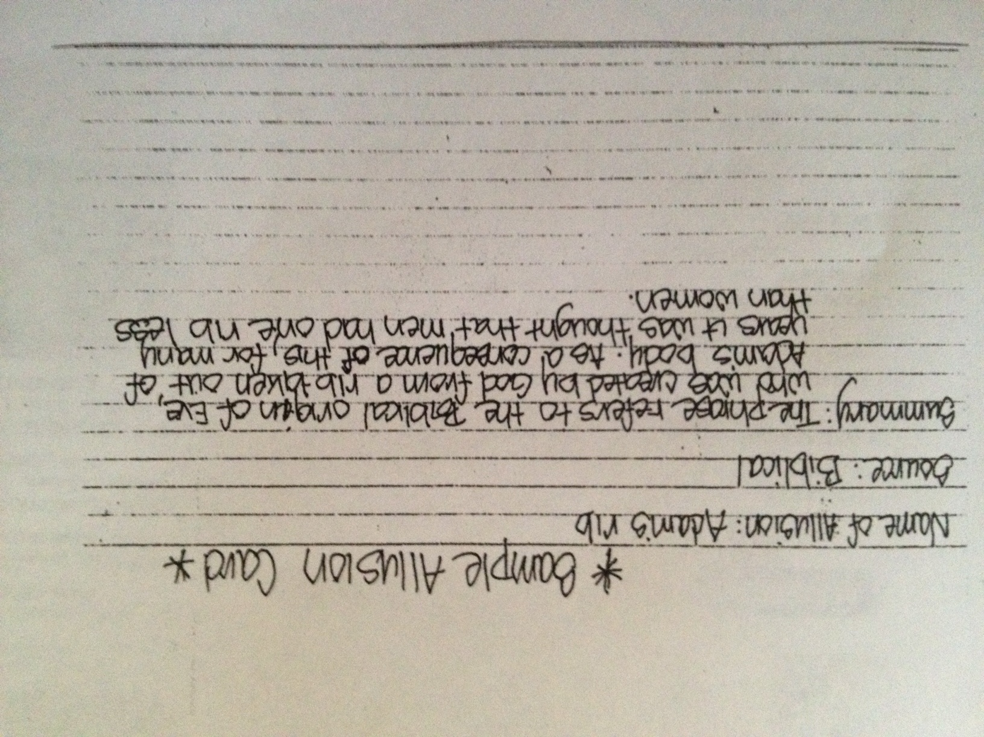

- Adam's rib
- Alpha and Omega
- Am I my brother's keeper?
- Ark of the Covenant
- Ashes to ashes, dust to dust
- Babel
- Be fruitful and multiply
- Bitter as wormwood
- Break bread
- Burning bush
- By their fruits shall ye know them
- Camel through the eye of a needle
- Cast the first stone
- Water into wine
- Chariot of fire
- Consider the lilies of the field
- Crown of thorns
- David and Goliath
- Daniel in the lion's den
- Doubting Thomas
- Eye for eye, tooth for tooth
- Forty days and forty nights
- Four Horsemen of the Apocalypse
- Gain the whole world but lose your own soul
- Gold, frankincense, and myrrh
- Golden calf
- Golden Rule
- Good Samaritan
- Harden your heart
- Jonah and the whale
- Lamb to the slaughter
- Let my people go
- Loaves and fishes
- Manna from heaven
- Mark of Cain
- Methuselah
- Noah's ark
- Parting of the waters
- Pearls before swine
- Prodigal son
- Sackcloth and ashes
- Seven pillars of Wisdom
- Sodom and Gomorrah
- Sufficient unto the day is the evil thereof
- Thirty pieces of silver
- This is my body
- Tree of Knowledge
- Turn the other cheek
- Voice crying in the wilderness
- Water into wine
- Way of all flesh
- White sepulchers
- Who lives by the sword shall die by the sword
- Wisdom of Solomon
- Word made flesh
- Ye cannot serve God and mammon

Part 3: Frankenstein

Read it. The whole thing. Make sure you know who the main characters are and some of the main themes or ideas. You might want to keep a reading journal (no, you don’t have to—but if you had my freshman year, you might want to keep a Dialectical Journal) to help you keep track of the events and characters. We will start the year off discussing this novel and if you have already read it, your first quarter as an AP student will be far easier.

